* Files permission

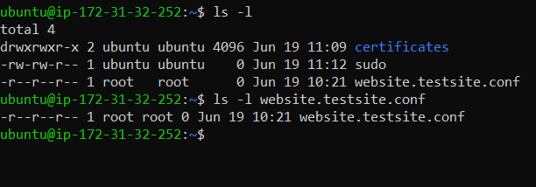

* Here we change our file permission now:-
* U = r ( user have only read permission )
* G = r (Group has already have only read permission)
* O = xr ( others have read and execute both permission)

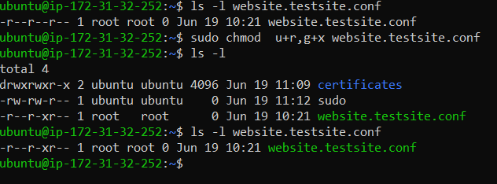

* Now we give more permission to user and group
* Previously user has only read permission now we give write & execute both permission.
* Previously group has only read permission now we give write & execute both permission.

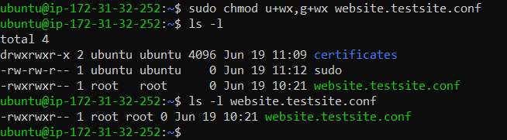

* No we remove some permission to user and group
* We give user only read & write permission
* we give group only read permission

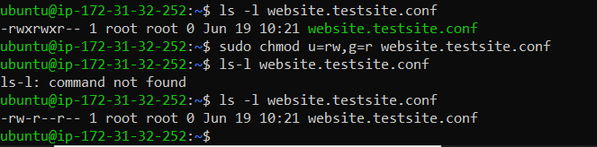

* We use a=r means, we have give a only read permission in whole user group and other.

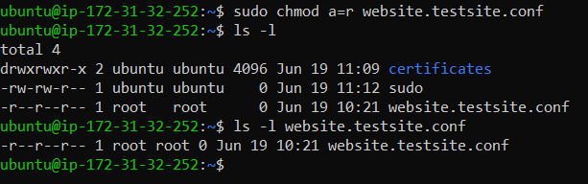

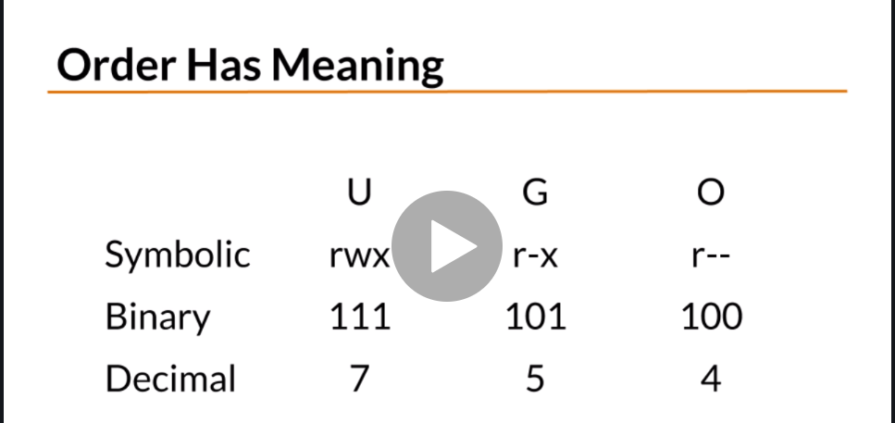

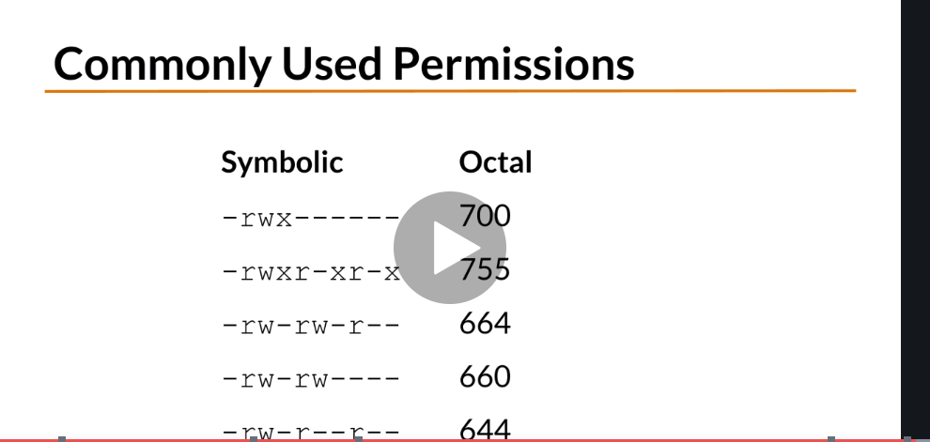

Changing File Ownership (chown, chgrp)

● In Linux, all files are associated with an owner and a group owner.

● The chown and chgrp commands are used to change the files owner and group.

● Only root can change the file owner.

● Normal users can change the group of the file only if they own the file and only to a group of which they are a member of. root can change the group ownership of all files.

**ls -l hello.c**

-rw-r--r-- 1 root root 81 iul 18 12:49 hello.c

**chown james hello.c**

**ls -l hello.c**

-rw-r--r-- 1 james root 81 iul 18 12:49 hello.c

**chgrp adm hello.c**

**ls -l hello.c**

-rw-r--r-- 1 james adm 81 iul 18 12:49 hello.c